
CS 120 Web Programming
Project 3

Deliverable Worksheet
Deliverable Worksheet
Yes All code files (combine into a compressed/zip file – do not add this deliverable worksheet to
the zip file)
Yes Paste screenshots of each table in the database below

Table: books
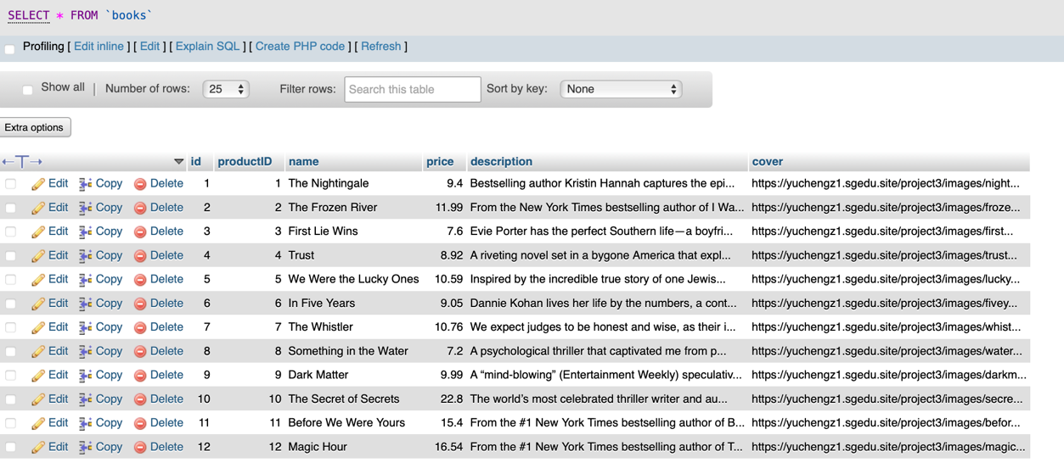
Table: orders
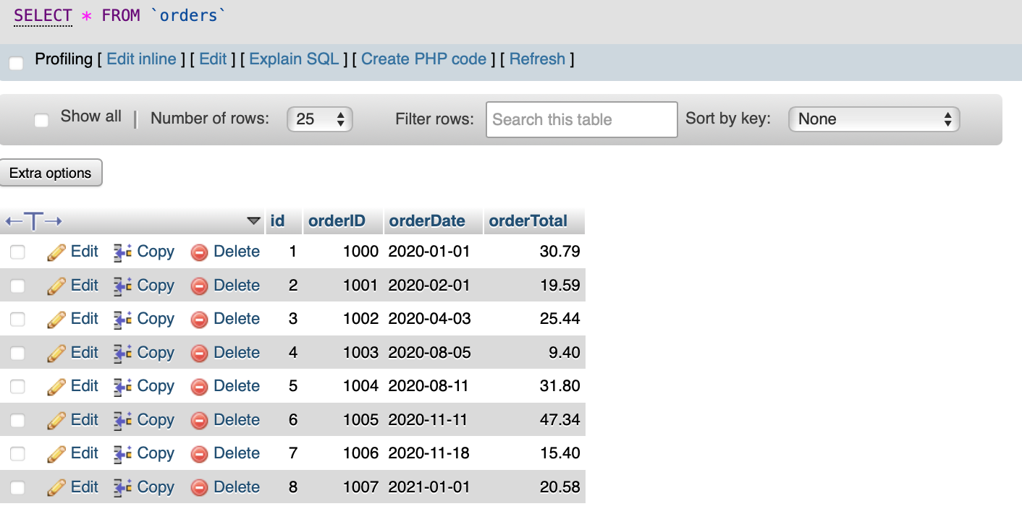

Table: order_items
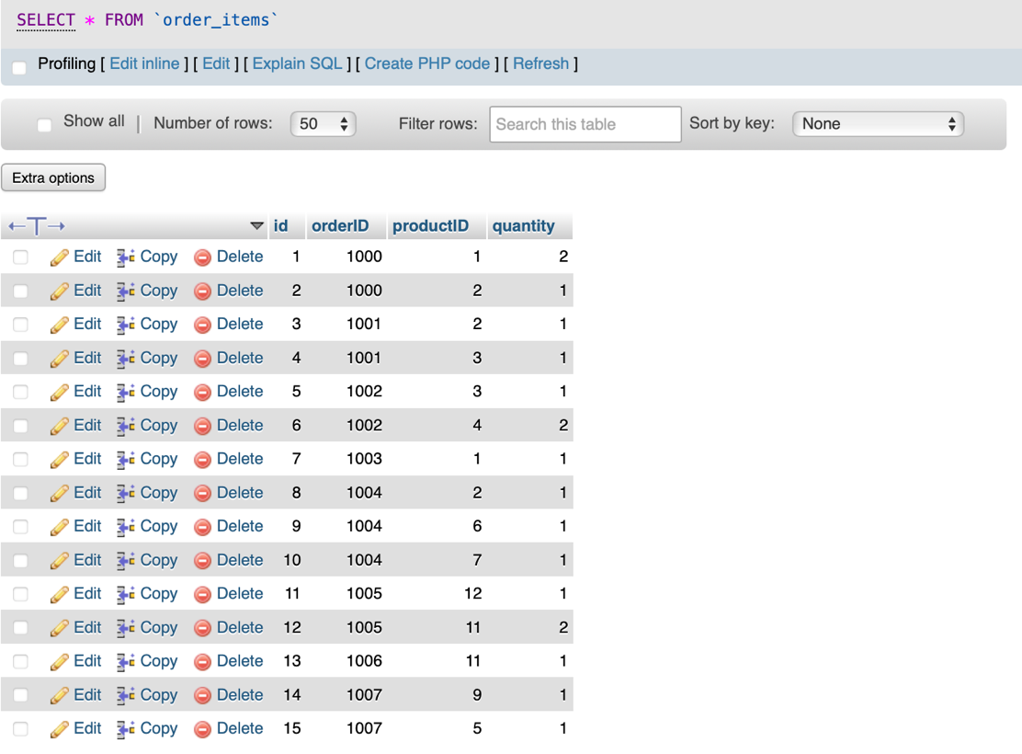

URL for product page: https://yuchengz1.sgedu.site/project3/products.php
URL for orders page: https://yuchengz1.sgedu.site/project3/orders.php

Project requirements- check off those you completed.
Yes Database created to store orders and products
Yes Products page
Yes Cart page
Yes “Thank you” page
Yes Orders page

Are there any extra features you added that are not listed above?
- I created three sql databases: books, orders and order_items. Among these, order_items is used as the assignment table. This allows unlimited products to be ordered.
- I used Bootstrap for the web design to simplify my web development, and ensure a clean, responsive and mobile-friendly user interface.
What was the most interesting part of this project?
The most interesting part of this project is integrating both the frontend(HTML, Javascript, and CSS) and backend (SQL and PHP) to build a fully functional website. Unlike temporary stored only in the browser, this project involves storing data permanently in SQL databases.

